A C H A U T H O R I Z AT I O N F O R M

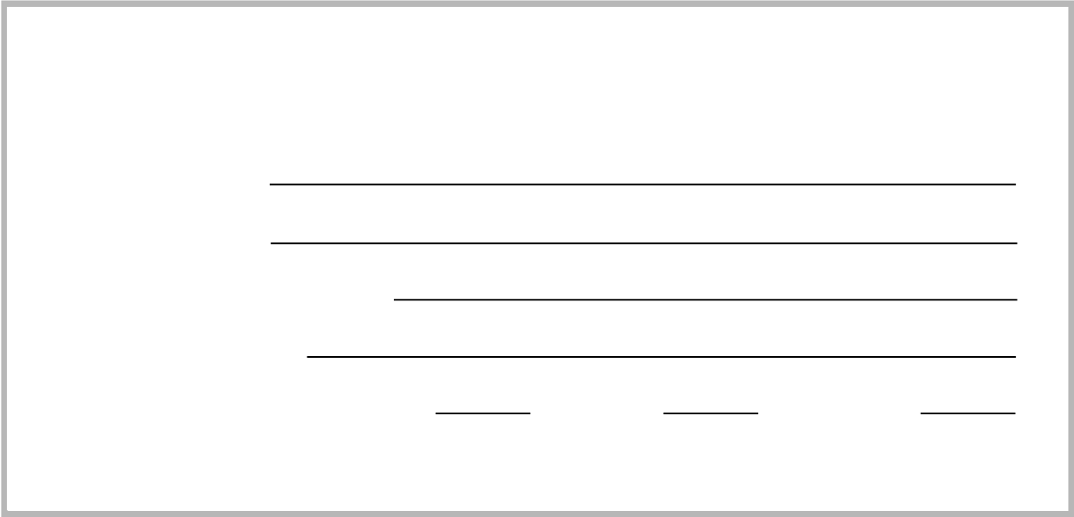

Name of Bank: Bank Address:

Bank Account Number: Routing Number:

Account Type: Check ing: Savings: Corporate: Beginning Date:

I (we) hereby certify that I am duly authorizing account holder fully empowered to legally bind the above referenced bank account. By signing as the account holder, I, hereby authorize Waterford Condominium Association, to initiate ACH debit entries to the financial account listed above in the amounts of each invoice. I understand that I am responsible for any fees if said ACH debit is rejected or returned for any reason.

*This authorization is to remain in full force and effect until Bright Management, on behalf of Waterford Condominium Association, has received written notification of its termination in such time and in such manner as to afford all financial institutions involved a reasonable opportunity to act on it. If there are any changes in the information provided in this authorization, it is responsibility to contact Caleb Bright (bright@waterford-hoa.com) of such changes*

Signature: __________________________________________________

Printed Name: _______________________________________________

Building #: _________ Unit #: __________